The basics of economics

Student: Class: Due date:

**1. All countries require an economic system. This is due to the basic economic problem. Explain this economic problem through the completion of the following diagram:**

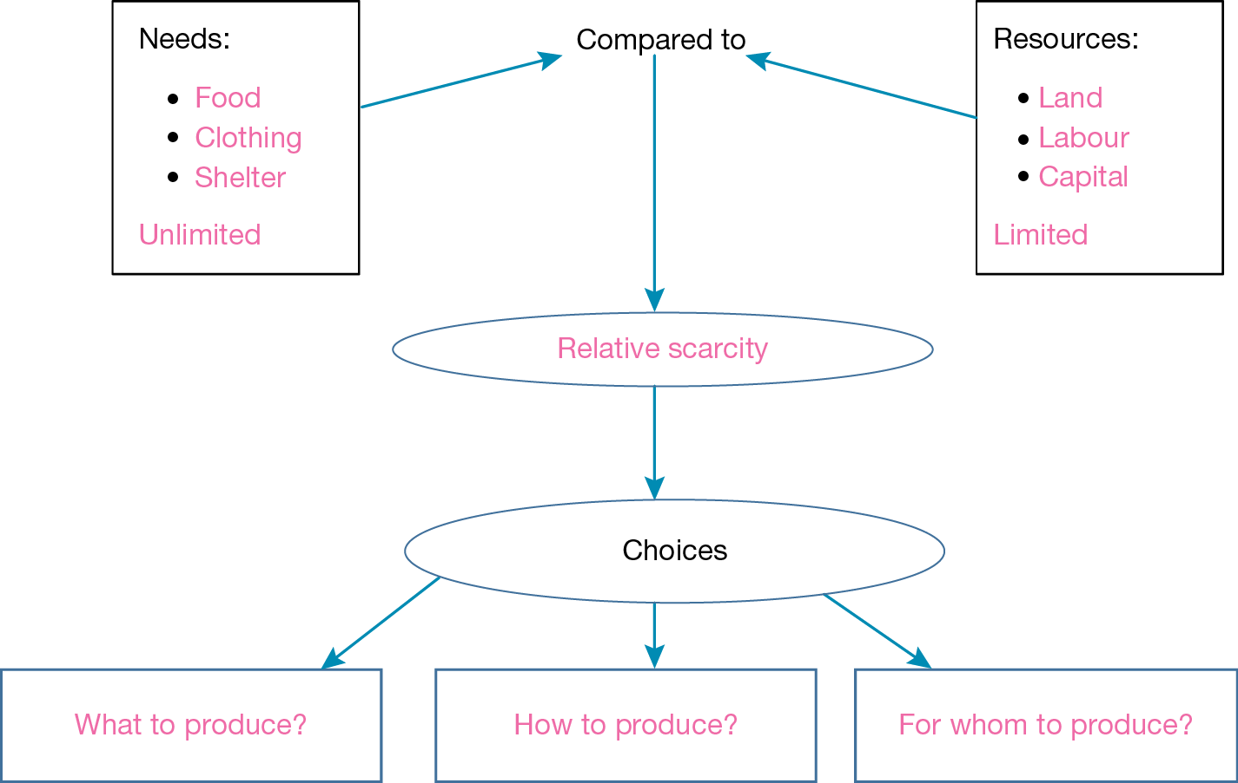



**2. In addition, an economy can show the relationship between the economic agents in an economy. Complete the five sector circular flow diagram of the Australian economy:**



